INTERNSHIP REPORT
ON
FULL STACK DEVELOPMENT
Internship at Hemnhue Private Limited
Submitted To
School of Computer Science and Engineering
IILM University, Greater Noida, U.P.
In partial fulfilment of the requirement of degree of
B.Tech CSE

By
SHYAMJI DWIVEDI
Class/Section: 3CSE3
Roll Number: 2410030495
Batch: 2024 – 28
Internship Period: 7 June 2026 – 29 August 2026
School of Computer Science and Engineering
IILM University, Greater Noida, U.P.
CANDIDATE’S DECLARATION
I, Shyamji Dwivedi, do hereby declare that the internship report titled “Full Stack Development” has been completed by me to fulfil the requirement for the award of the degree of Bachelor of Technology in Computer Science and Engineering. This report presents my internship experience at Hemnhue Private Limited during the period from 7 June 2026 to 29 August 2026.
The report has been prepared on the basis of the internship completion certificate issued by the organisation and my internship learning and work areas. I affirm that this report is my own work and has not been submitted to any other institute for any degree or diploma requirement. I shall be solely responsible for any kind of copyright violation in this regard.
Where specific implementation details such as programming languages, frameworks, database engines, IDEs, or a named software product are not stated in the internship certificate, they have not been represented as confirmed facts in this report.

Signature:
Student Name: Shyamji Dwivedi
Roll No.: 2410030495

ACKNOWLEDGEMENT
I take this opportunity to express my sincere gratitude to everyone who supported me throughout my internship programme. I am thankful for the guidance, constructive criticism, encouragement, and professional advice that helped me learn and improve during the internship.
I am grateful to Hemnhue Private Limited for providing me with the opportunity to work as a Full Stack Developer Intern and for giving me exposure to practical software development activities. The internship helped me understand how frontend development, backend integration, database management, API development, debugging, and application testing contribute to the development of a complete software application.
I would also like to express my gratitude to the faculty members and the School of Computer Science and Engineering, IILM University, for their academic support. Finally, I express my gratitude to my parents for their blessings and constant encouragement.

Signature:
Student Name: Shyamji Dwivedi
Roll No.: 2410030495
INTERNSHIP COMPLETION CERTIFICATE
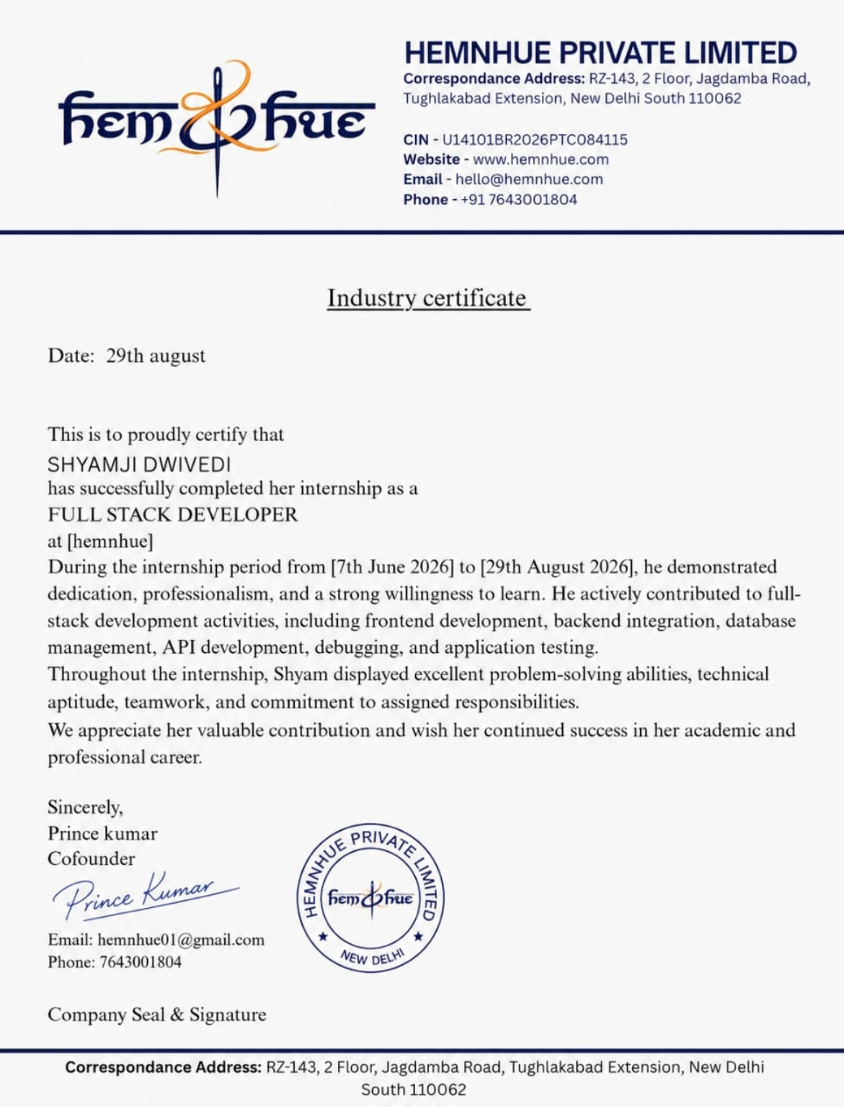
TABLE OF CONTENTS
Chapter No. | Chapter Name | Page No.
1 | Candidate’s Declaration | i
2 | Acknowledgement | ii
3 | Internship Completion Certificate | —
4 | Project Description | 1
4.1 | Introduction | 1
4.2 | Organization Profile | 2
4.3 | Problem Statement | 3
4.4 | Project Objectives | 3
4.5 | Scope of the Project | 4
4.6 | Technologies and Tools Used | 5
4.7 | System Architecture | 6
4.8 | Methodology | 7
4.9 | Expected Outcomes | 9
4.10 | Certificates of Completion and Other Communication Mail Proof | 10
5 | Bibliography / References | 11

LIST OF TABLES AND FIGURES
No. | Description | Page No.
Table 4.1 | Organisation details | 2
Table 4.2 | Internship work areas and learning focus | 4
Table 4.3 | Technology and tool areas | 5
Table 4.4 | Methodology steps | 7
Figure 4.1 | Conceptual system architecture | 6

CHAPTER 4
PROJECT DESCRIPTION

4.1 Introduction
The internship at Hemnhue Private Limited was completed in the role of Full Stack Developer from 7 June 2026 to 29 August 2026. The internship provided practical exposure to activities involved in developing and supporting software applications across the frontend and backend layers.
According to the internship completion certificate, the major areas of contribution included frontend development, backend integration, database management, API development, debugging, and application testing. These activities provided an opportunity to connect academic concepts from computer science with practical software development practices.
This report documents the internship in a structured manner. Since the completion certificate does not identify a particular application, programming language, framework, or database product, the report focuses on the confirmed work areas rather than attributing unverified technologies or project names to the internship.

4.2 Organization Profile
Hemnhue Private Limited is the organisation named on the internship completion certificate. The certificate provides the following organisation and internship details.
Particular | Details
Organisation | Hemnhue Private Limited
Internship Role | Full Stack Developer
Correspondence Address | RZ-143, 2 Floor, Jagdamba Road, Tughlakabad Extension, New Delhi South 110062
Website | www.hemnhue.com
Email | hello@hemnhue.com
Phone | +91 7643001804
Internship Period | 7 June 2026 – 29 August 2026
Table 4.1: Organisation and internship details as stated on the supplied internship completion certificate.
The organisation profile above is limited to information appearing on the issued certificate. No additional claims about the company’s size, history, products, clients, or business operations are made here because those details are not provided in the supplied certificate.

4.3 Problem Statement
Modern software applications require coordinated development of user interfaces, server-side functionality, data storage, application programming interfaces, and quality assurance activities. A learner working only with theoretical concepts may have limited exposure to how these components are integrated in a practical development environment.
The internship addressed this learning gap by providing practical involvement in full-stack development activities. The work required understanding frontend requirements, connecting backend services, managing application data, developing APIs, debugging issues, and testing application behaviour.

4.4 Project Objectives
• To gain practical exposure to full-stack software development activities.
• To strengthen understanding of frontend development and user-facing application components.
• To understand backend integration and the role of server-side functionality.
• To develop practical understanding of database management and data handling.
• To understand API development and integration between application components.
• To improve debugging, problem-solving, and application testing skills.
• To develop professional discipline, teamwork, and responsibility while working on assigned tasks.

4.5 Scope of the Project
The scope of this internship report covers the software development activities explicitly identified in the completion certificate. The scope includes frontend development, backend integration, database management, API development, debugging, and application testing.
Area | Scope Covered | Learning Focus
Frontend Development | Development and refinement of user-facing application components. | UI structure, usability, and interaction.
Backend Integration | Connecting frontend components with server-side functionality. | Application flow and service integration.
Database Management | Handling application data and database-related activities. | Data storage, retrieval, and consistency.
API Development | Creating or working with APIs for application communication. | Request/response flow and integration.
Debugging | Identifying and resolving application issues. | Problem solving and fault isolation.
Application Testing | Checking application behaviour and functionality. | Validation, reliability, and quality.
Table 4.2: Internship work areas and corresponding learning focus.

4.6 Technologies and Tools Used
The internship certificate identifies technology-related work areas but does not list specific programming languages, frameworks, database products, IDEs, or version-control platforms. Therefore, the following table records the technology categories confirmed by the certificate without inventing product names.
Technology / Tool Area | Role in Development | Relevant Skills
Frontend Development | Build and refine the user-facing part of an application. | UI development, layout, interaction, usability.
Backend Integration | Connect the frontend with server-side functionality. | Service integration, application flow.
Database Management | Store, retrieve, and manage application data. | Data handling and database operations.
API Development | Enable communication between application components. | API design, requests, responses, integration.
Debugging | Locate and resolve defects or unexpected behaviour. | Error analysis, troubleshooting, problem solving.
Application Testing | Verify application functions and behaviour. | Functional validation, defect identification.
Table 4.3: Technology and tool areas confirmed by the internship certificate.

4.7 System Architecture
A representative three-layer architecture is used below to document how the internship work areas can relate to one another. This is a conceptual representation for report purposes; the supplied certificate does not specify the actual architecture of a particular application.
USER / CLIENT LAYER
Frontend / User Interface
↓
APPLICATION LAYER
Backend Integration | API Development
↓
DATA LAYER
Database Management / Application Data
↕
QUALITY & SUPPORT
Debugging | Application Testing
Figure 4.1: Conceptual architecture connecting the frontend, backend/API, database, and quality activities described in the internship certificate.

4.8 Methodology
Step | Activity | Purpose
1 | Requirement Understanding | Understand the assigned task, expected application behaviour, and interaction between the relevant components.
2 | Frontend Development | Work on the user-facing portion of the application and refine the interface according to requirements.
3 | Backend Integration | Connect frontend components with backend services and ensure the expected application flow.
4 | Database Management | Work with application data and database-related operations required by the software.
5 | API Development | Develop or integrate APIs to support communication between application components.
6 | Debugging | Identify errors, trace their causes, and apply suitable corrections.
7 | Application Testing | Test application functions and interactions to identify defects and verify expected behaviour.
8 | Review and Improvement | Refine the implementation based on testing results and assigned feedback.
Table 4.4: Structured methodology based on the internship work areas stated in the certificate.
The methodology is presented as a practical development cycle. The exact task sequence followed inside the organisation is not stated in the certificate; therefore, this sequence is a structured documentation of the confirmed internship work areas rather than a claim about a proprietary company process.

4.8 Methodology (continued)
1. Understanding the task: The first step in a development assignment is to understand the expected functionality and identify the application components involved.
2. Building the frontend: The user-facing interface is developed or refined so that users can interact with the required functionality.
3. Connecting backend services: Frontend components are integrated with backend functionality so that application requests can be processed correctly.
4. Managing data: Database-related activities are performed to store and retrieve the information required by the application.
5. Working with APIs: APIs provide a structured way for application components to communicate. API-related work supports data exchange and integration.
6. Debugging and troubleshooting: Issues are analysed systematically by reproducing the problem, locating the relevant component, applying a correction, and checking the result.
7. Testing: Application functionality is checked after implementation or changes. Testing helps identify defects and confirms whether the expected behaviour is achieved.
8. Iterative improvement: The development process is improved through repeated implementation, testing, debugging, and refinement.

Skills and Professional Learning
• Understanding of the relationship between frontend, backend, APIs, and databases.
• Improved problem-solving through debugging and troubleshooting.
• Practical awareness of application testing and quality checks.
• Better understanding of data flow between different software components.
• Improved ability to work on assigned development responsibilities.
• Professional discipline, teamwork, and willingness to learn.

4.9 Expected Outcomes
• Practical understanding of full-stack development workflows.
• Improved ability to work with frontend and backend application components.
• Better understanding of database-related development activities.
• Ability to understand and work with API-based application communication.
• Improved debugging and application testing capability.
• Greater confidence in approaching real-world software development assignments.
• Development of professional habits such as responsibility, teamwork, and continuous learning.

4.10 Certificates of Completion and Other Communication Mail Proof
A copy of the internship completion certificate issued by Hemnhue Private Limited is included in Chapter 3 of this report. The certificate confirms successful completion of the Full Stack Developer internship during the period from 7 June 2026 to 29 August 2026 and records the work areas of frontend development, backend integration, database management, API development, debugging, and application testing.
The supplied material for this report contains the internship certificate but does not include separate communication emails or additional mail proof. Therefore, no email communication has been represented as evidence in this report. If required by the university, the student may attach printed copies of relevant internship communication separately in the final submission.

CHAPTER 5
BIBLIOGRAPHY / REFERENCES
[1] Hemnhue Private Limited, “Industry Certificate,” issued to SHYAMJI DWIVEDI, dated 29 August 2026, Internship period: 7 June 2026 – 29 August 2026.
[2] IILM University, School of Computer Science and Engineering, “Internship Report Format updated 26-27,” supplied report template and formatting instructions.
[3] MDN Web Docs, “Web development technologies,” Mozilla Developer Network. Reference material for general web-development concepts.
[4] R. T. Fielding, “Architectural Styles and the Design of Network-based Software Architectures,” Doctoral dissertation, University of California, Irvine, 2000. Reference material for REST and network-based application architecture.
[5] OWASP Foundation, “OWASP Top 10,” reference material for general web-application security awareness.

